AIM
To apply Perspective Transformation on an image to change its viewpoint so that the image appears as if seen from another angle (like turning a rectangle into a trapezoid or correcting a skew).
- IINPUT
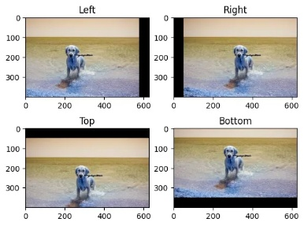
- i
OUTPUT
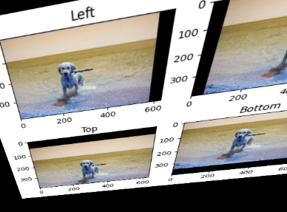
ALGORITHM
- Start the program.
- Import OpenCV and NumPy libraries.
- Load the input image.
- Select four points from the original image.
- Select four new points defining the desired transformed shape.
- Use cv2.getPerspectiveTransform() to get the transformation matrix.
- Apply the transform using cv2.warpPerspective().
- Display and save the result.
- End the program.
RESULT
Perspective transformation changes the viewing angle of an image.
Straight lines remain straight, and you get a new warped or corrected view depending on the chosen points.

